**SYSC 5104**

**ASSIGNMENT 2**

**Methodologies for Discrete Event**

**Modelling and Simulation**

**November 24, 2017**

**Submitted By:**

**Seerat Kaur**

**101089616**

**Table of contents**

|  |  |
| --- | --- |
| **1.** | **Introduction**   * 1. Cystogenesis in Biological Terms   2. Global Dynamics |
| **2.** | **Cellular Automation**  2.1 General Variables  2.2 Cell and Cell states |
| **3.** | **Simulation Visualization** |

**ABSTRACT**

Cystogenesis is the process of formation of cysts from the cells. This process is important for the formation of a variety of tissues. My model focuses on the generation of a cyst from cluster of cells that do not initially have lumen. Cystogenesis is initiated by the formation of an aggregate of cells through proliferation. This model will be referred to as Cell DEVS model.

**1.Introduction**

**1.1 CYSTOGENESIS IN BIOLOGICAL TERMS**

**Three Surface Pursuit (TCP)**

Cysts are hollow structures enclosed by a layer of cells. Once an aggregate of cells has formed, cyst formation is driven by a “three-surface pursuit” (TSP):

* The first surface, in contact with the ECM, is the basal membrane.
* The second surface, which is in contact with other cells, is referred to as the lateral membrane.
* The third surface, in contact with the lumen, is the apical membrane.

Upon initiation of the three-surfaces pursuit, the aggregate of cells creates these three surfaces through a combination of membrane separation, apoptosis, and directed protein delivery. In some systems, the apical membrane is defined when the cyst’s inner cells die through apoptosis (programmed cell death) and form the lumen. In other systems, including MDCK cells, the apical surface is first brought about through the coalescence of vesicles (followed by apoptosis of any cells left in the lumen). Proliferation and adhesion caused by DAH forces lead to an aggregate of cells. This aggregate becomes a cyst through TSP.

**1.2 The Global Dynamics** The global dynamics encapsulate the various large-scale transitions that the system goes through (e.g. the epithelial-mesenchymal transition) and are implemented via a simple Signaling mechanism. Signals have three important characteristics:

(i) they are a single time-point events.

(ii) they cannot directly change the local dynamics, and

(iii) being global events they can target many or all cells.

In my model, signals affect the system by changing cell states. In particular, modelling the triphasic hypothesis, our model incorporates 3 distinct signals:

**Proliferation and Adhesion (DAH)**: Changes all cells except for Apical cells to Growing cells. This allows cells to grow into an aggregate, but keeps an already formed cyst from changing. Mesenchymal cells turn into Growing cells with probability *Pm*2*g* (0*.*6 in our simulation) to prevent overgrowth of the cell cord.

**Three Surface Pursuit (TSP)**: Changes all cells in contact with the ECM to Apical cells, and all other cells to Apoptosis cells. These cells also start forming vesicles.

**Epithelial-Mesenchymal Transition (EMT)**: The signal is assumed to originate from the right side of the lattice and changes the cell closest to the source of the signal to a Growing-chain cell.

**2.** **CELLULAR AUTOMATION**

The rules of the cellular automaton accounted for growth of cysts, the movement of active cells, and the interaction between apical and growing cells. A cyst is a agregate of cyst cells that grow in a pattern resembling three concentric circles. The proliferative cells on the outside tend to form a ring around growing cells, which in turn encircle the apical cells which ultimately dissolves to form a fluid. This fluid tends to fill the inside of the cyst.

**2.1. General Variables**

|  |
| --- |
| [CYST]  type : cell  dim : (21,21)  delay : transport  defaultDelayTime : #Macro(d)  border : wrapped  initialvalue : -1  localtransition : tau |

The **CYST** function represents cell-space for cyst formation.

* **t1** , **t2** represents dimensions of the cell space. The cell space is 2-dimensional.
* **d** is the delay for each cell.
* **p** represents different signals that influence the behavior of the different states of the model.

$$n=2$$

The model has neither inputs nor outputs.

$$X_{list}=Y_{list}=X=Y=∅$$

The 5-by-5 cell square neighborhood is centered on each cell.

$$N=\text{\{<}i,j\text{>}∣\text{(}i∈\text{\{}-2,-1,0,1,2\text{\})}∧\text{(}j∈\text{\{}-2,-1,0,1,2\text{\})\}}$$

* The borders of the model are **wrapped** in order to ensure that the growing cells on the border are not completely removed from the model**.**

The translation function **Z** is defined as in the formal specification of Cell-DEVS.

The entire **t1**-by-**t2** cell space is occupied by timed DEVS cells, each of which has the same specification.

$$C=\text{\{}C_{ij}∣\text{(}i∈Z\text{)}∧\text{(}0≤i<t_{1}\text{)}∧\text{(}j∈Z\text{)}∧\text{(}0≤j<t_{2}\text{)\}}$$

(where...)

$$C_{ij}=\text{<}X_{C},Y_{C},S,N,delay,d,δ_{\text{int}},δ_{ext},τ,λ,D\text{>}$$

As was the case for the cell-space, the DEVS cells have neither input nor output values.

$$X_{C}=Y_{C}=∅$$

The state associated with each individual cell consists of both a type and a direction. The type indicates whether the represented biological cell is a normal, immunity, proliferative, dormant, or necro cell. The direction, which is either <0, 0> or the coordinates of an adjacent cell, indicates either the way active cells are moving or the way they are dividing.

$$S=\text{\{<}type,direction\text{>}∣\text{(}type∈types\text{)}∧\text{(}direction∈directions\text{)\}}$$

(where...)

$$types=\text{\{}active,growing,proliferative,apical,apoptosis\text{\}}$$

(and...)

$$directions=\text{\{<}i,j\text{>}∣\text{(}i∈\text{\{}-1,0,1\text{\})}∧\text{(}j∈\text{\{}-1,0,1\text{\})\}}$$

The model uses transport delays.

$$delay=transport$$

The variables **δint**, **δext**, **λ**, and **D** are defined as in the formal specification of Cell-DEVS. The following subsections define the local computing function **τ**.

**2.3. Cell and Cell states**

$$τ\text{(}s\text{)}=\left[\begin{matrix}type\text{(<}0,0\text{>)}=active & → & τ_{active}\text{(}s\text{)} \\ type\text{(<}0,0\text{>)}=growing & → & τ_{growing}\text{(}s\text{)} \\ type\text{(<}0,0\text{>)}=proliferative & → & τ_{proliferative}\text{(}s\text{)} \\ type\text{(<}0,0\text{>)}=apical & → & τ_{apical}\text{(}s\text{)} \\ type\text{(<}0,0\text{>)}=fluid & → & τ_{fluid}\text{(}s\text{)}\end{matrix}\right]$$

**τ** depends on the functions **τactive**, **τgrowing**, **τproliferative**, **τapical**, and **τfluid**.

**Active Cell**: The simulation starts with Active cells which are further converted into

growing cells once the DAH signal is triggered.

**Growing Cell**: These cells start building a ball outside the cyst which is the crust of the cyst.

**Proliferative Cell**: a cyst cell that divides, facilitating the growth of a cyst.

**Apical Cell**: These cells dissolve inside the ball forming a fluid inside the cyst.

**Fluid**: at the end, the apical cells are converted into fluid like material that fills the inside of the cyst.

**3. Simulation Visualization**

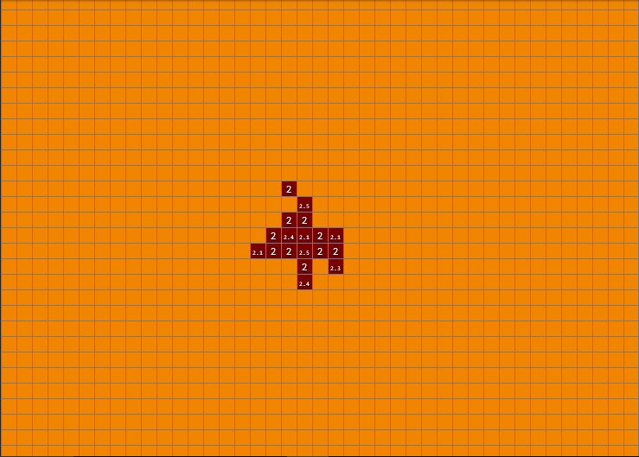

This figure shows the active state of the cell which is converted into growing cells**.** Basically the picture represents cell division. The active cells start growing and constructing a ball of cells.

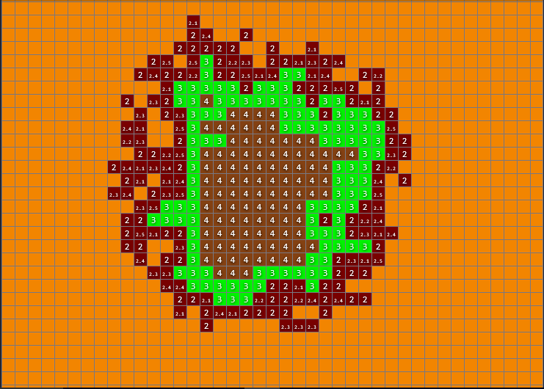

In the above picture, the internal cells start dissolving forming a fluid filled cyst. The green

color represents the apical cells that are dissolving to form fluid which is represented with brown color.

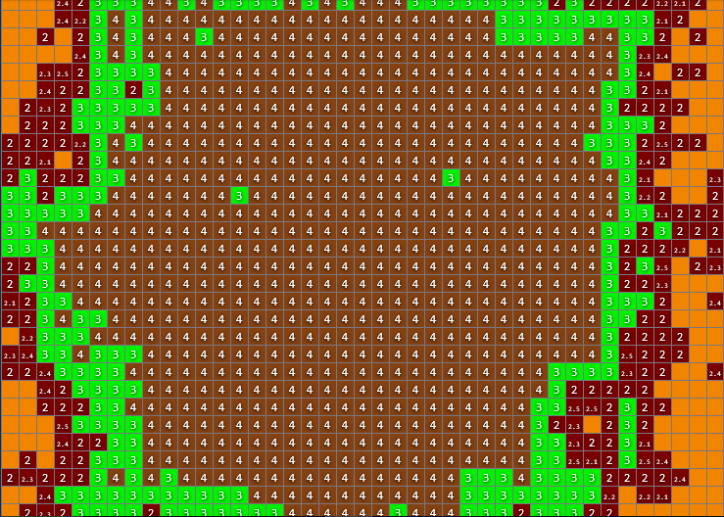

As the size of the cyst increases with time, all the apical cells (represented by green color) tends to dissolve and form fluid which fills the inside of the cyst. This picture simply represents the growth of already formed cyst with fluid inside and hard crust outside.